**Part-1**

**Question-1:** What is the ciphertext when encrypting "send_money" with the key "security" and alphabet abcdefghijklmnopqrstuvwxyz_.?

**Ans:** iipxpufjwa

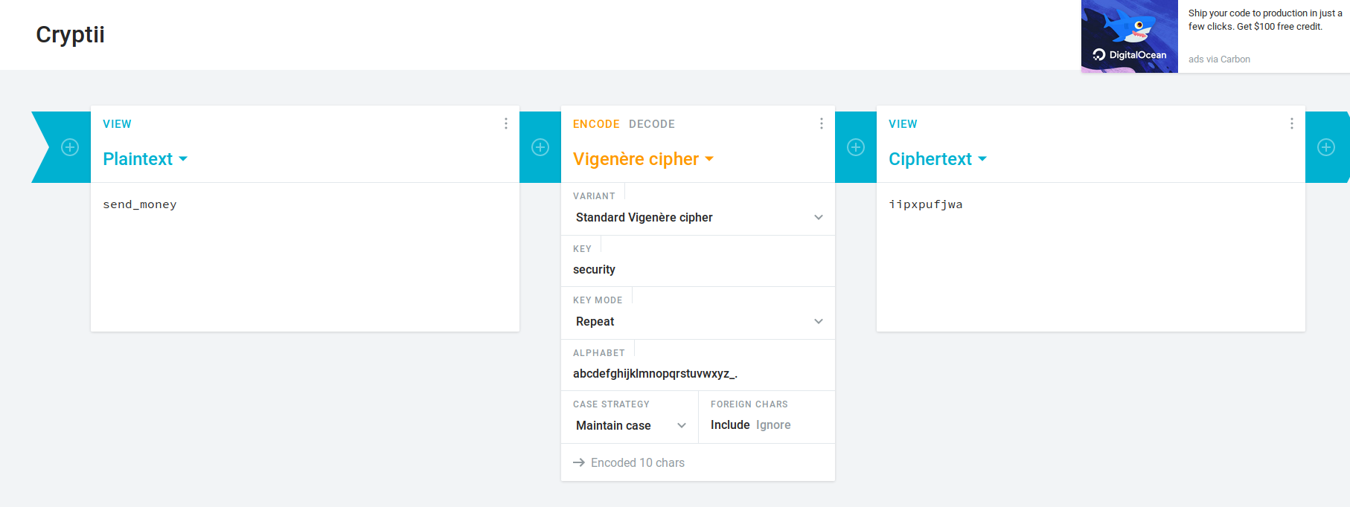

**Question-2:** What is the ciphertext when encrypting "attack postponed until two am" with the provided key

**Ans: TPITTTKEWCNTASNMPDOAOLOUA**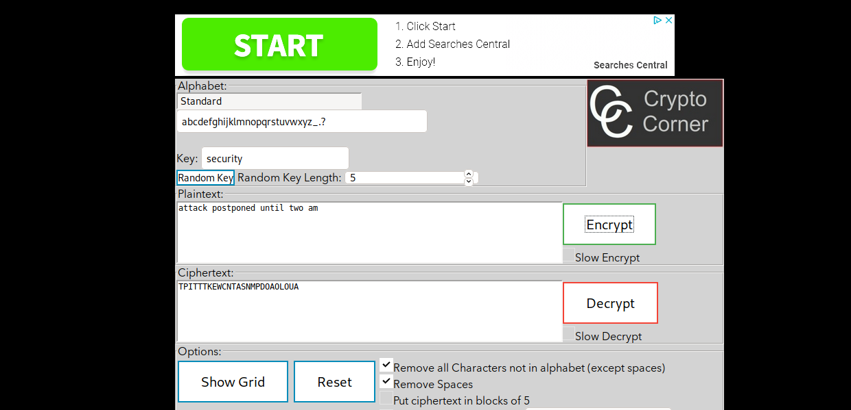

**Frequency Analysis**

Questions: 1. What are the four most frequent characters, in descending order? Examine the frequency table chart at h ttp://en.wikipedia.org/wiki/Frequency_analysis. What does this suggest the four letters identified correspond to?

Question: What are the four most frequent characters?

Ans: S,H,W,G

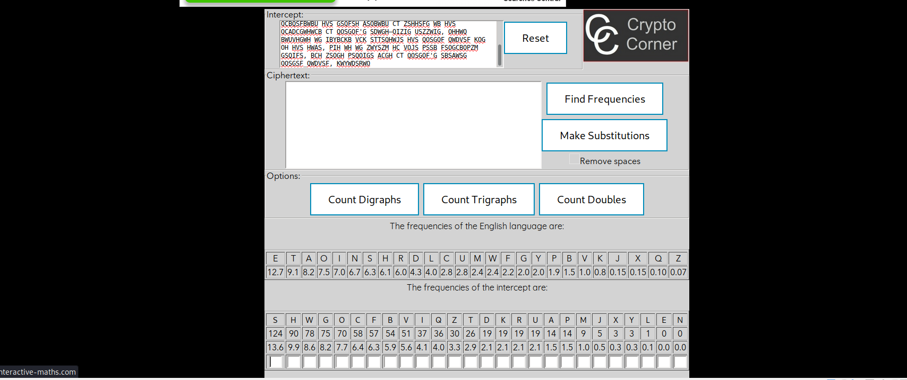

2. Analyze bigrams and trigrams in the ciphertext. What do the most frequent ciphertext bigrams suggest the three 2-length N-grams identified correspond to in English plaintext? Also examine N-grams of length 3 and report the likely plaintext identities of the four 3-length N-grams reported. (Use h ttp://en.wikipedia.org/wiki/Trigram).

Question: What are the three most frequent trigrams?

Ans: 

The most common trigraphs in the english language are:

THE, AND,THA,ENT,ION,TIO,FOR,NDE,HAS,NCE,TIS,OFT,MEN

The most common trigraphs in the message are:

HVS,VSF,QOS,OSG,QWD,DVS,WIG,WBU,SGO,GOF,WDV,HSF,ZWI

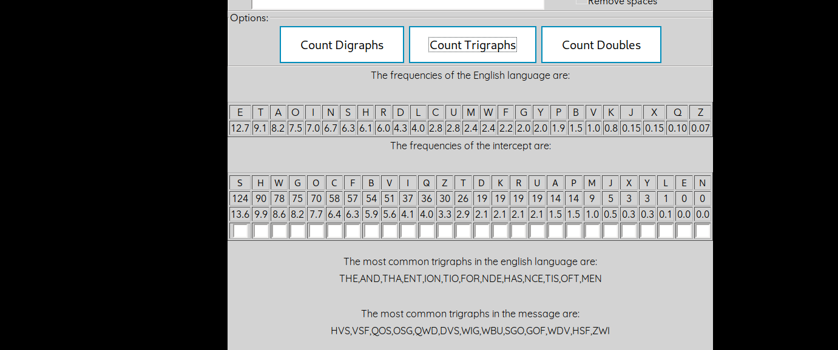

3. Assume that a simple cipher that shifts all characters by a fixed number was used to create the cipertext. Given the results of the frequency analysis, what would the shift key have been (the shift to go from plaintext to ciphertext)? Don’t be proud; you can use your fingers to count.

Question: What is the key of the ciphertext, counting forwards?

Ans: The key is 14

4. What is the plaintext? Question: What author is quoted in the plaintext? SUETONIUS

Ans: THE CAESAR CIPHER IS NAMED AFTER JULIUS CAESAR, WHO, ACCORDING TO SUETONIUS, USED IT WITH A SHIFT OF THREE TO PROTECT MESSAGES OF MILITARY SIGNIFICANCE. W IF HE HAD ANYTHING CONFIDENTIAL TO SAY, HE WROTE IT IN CIPHER, THAT IS, BY SO CHANGING THE ORDER OF THE LETTERS OF THE ALPHABET, THAT NOT A WORD COULD BE—SUETONIUS, LIFE OF JULIUS CAESAR 56HIS NEPHEW, AUGUSTUS, ALSO USED THE CIPHER, BUT WITH A RIGHT SHIFT OF ONE, AND IT DID NOT WRAP AROUND TO THE BEGINNING OF THE ALPHABET: WHENEVER HE WROTE IN CIPHER, HE WROTE B FOR A, C FOR B, AND THE REST OF THE LETTERS ON THE SAME PRINCIPLE, USING AA FOR X.—SUETONIUS, LIFE OF AUGUSTUS 88THERE IS EVIDENCE THAT JULIUS CAESAR USED MORE COMPLICATED SYSTEMS AS WELL, AND ONE WRITER, AULUS GELLIUS, REFERS TO A (NOW LOST) TREATISE ON HIS CIPHERS: THERE IS EVEN A RATHER INGENIOUSLY WRITTEN TREATISE BY THE GRAMMARIAN PROBUS CONCERNING THE SECRET MEANING OF LETTERS IN THE COMPOSITION OF CAESAR'S EPIST—AULUS GELLIUS, ATTIC NIGHTSIT IS UNKNOWN HOW EFFECTIVE THE CAESAR CIPHER WAS AT THE TIME, BUT IT IS LIKELY TO HAVE BEEN REASONABLY SECURE, NOT LEAST BECAUSE MOST OF CAESAR'S ENEMIES CAESER_CIPHER, WIKIPEDIA

Ciphertext (hexadecimal): E0 C5 B5 B0 82 9A 8A DA B8 FD 8A 9E 67 5A 57

1. One-time pad 1: A1 B1 C1 D1 E1 F1 AA BB CC DD EE FF 10 34 76

Question: What is the plaintext using the one-time pad 1?

Ans: Attack at dawn!

2. One-time pad 2: B2 A0 C1 C2 E7 FB FE FA D9 89 AA AF 56 6A 67

Question: What is the plaintext using the one-time pad 2?

Ans: Retreat at 1100

3. One-time pad 3: B3 B0 C7 C2 E7 F4 EE BF CA DD EC F1 15 2E 76

Question: What is the plaintext using the one-time pad 3?

Ans: Surrender fort!

4. One-time pad 4: B4 AD D0 90 E1 FB FE FA D1 8E AA FA 02 3B 33

Question: What is the plaintext using the one-time pad 4?

Ans: The cat is dead

Question: How many possible plaintexts exist for this one-time-pad ciphertext?

Ans: Infinite

**Part-2 Hashing**

Questions:

1. What is the length of each of the following algorithm hashes in bytes? MD5, SHA-1, SHA-256, SHA-512? How many bits does each hash represent?

Ans: MD5 : 16 bytes(128 bits) , SHA-1 : 20 bytes(160 bits) , SHA-256: 32 bytes(256bits) , SHA-512: 64 bytes(512bits)

(hint: how many bits are in one hex digit – also called a ‘nibble’? How many nibbles in the key? Or, How many bits in a byte, and how many bytes in a two-digit hex number like ‘FA’? Review this if you’re still stuck)

Question: How many bits are in an MD5 hash?

Ans: 128 bits

Ans: db bd 83 7f 3a 12 3e f1 8b a5 2e 01 7a fb aa 8c (Bytes)

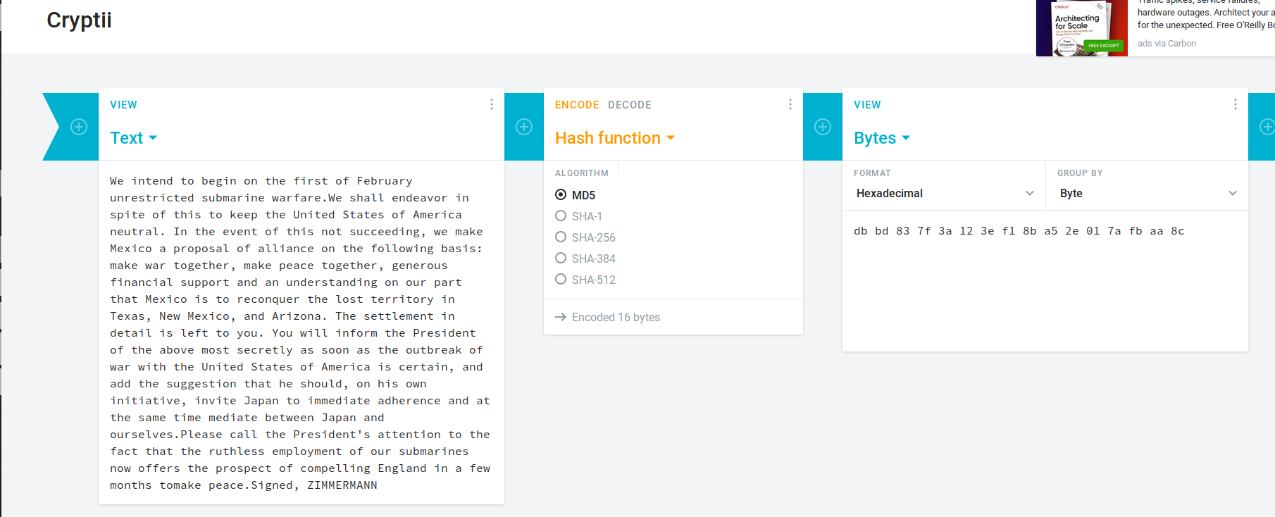

* 16*8 = 128 bits

Change just a single bit in content that you are hashing. e.g, change an “A” — 1010 to a B — 1011. Examine the hashes of the modified content. Since you only changed a single bit in a file of billions of bits, you might reason that the hashes would be nearly the same. Are they?

In cryptii, you can switch to a hex view thusly in order to make your single-bit-edit easier:

Question: Assume a 10 GB file is hashed. If only one bit is changed on a 10 GB file and then it is hashed again, how will the second hash compare to the first?

Ans: Completely different new hash value will be generated if only one single bit is changed in the 10GB file.

Question: Which property of cryptographic hash functions is most related to the previous question?

Ans: In cryptography, the avalanche effect is the desirable property of cryptographic algorithms, typically block ciphers and cryptographic hash functions, wherein if an input is changed slightly (for example, flipping a single bit), the output changes significantly (e.g., half the output bits flip). In the case of high-quality block ciphers, such a small change in either the key or the plaintext should cause a drastic change in the ciphertext. The actual term was first used by Horst Feistel, although the concept dates back to at least Shannon's diffusion.

The SHA-1 hash function exhibits good avalanche effect. When a single bit is changed the hash sum becomes completely different.

If a block cipher or cryptographic hash function does not exhibit the avalanche effect to a significant degree, then it has poor randomization, and thus a cryptanalyst can make predictions about the input, being given only the output. This may be sufficient to partially or completely break the algorithm. Thus, the avalanche effect is a desirable condition from the point of view of the designer of the cryptographic algorithm or device.

Constructing a cipher or hash to exhibit a substantial avalanche effect is one of the primary design objectives, and mathematically the construction takes advantage of the butterfly effect. This is why most block ciphers are product ciphers. It is also why hash functions have large data blocks. Both of these features allow small changes to propagate rapidly through iterations of the algorithm, such that every bit of the output should depend on every bit of the input before the algorithm terminates.

**Symmetric Encryption with AES**

What is the plaintext of the message?

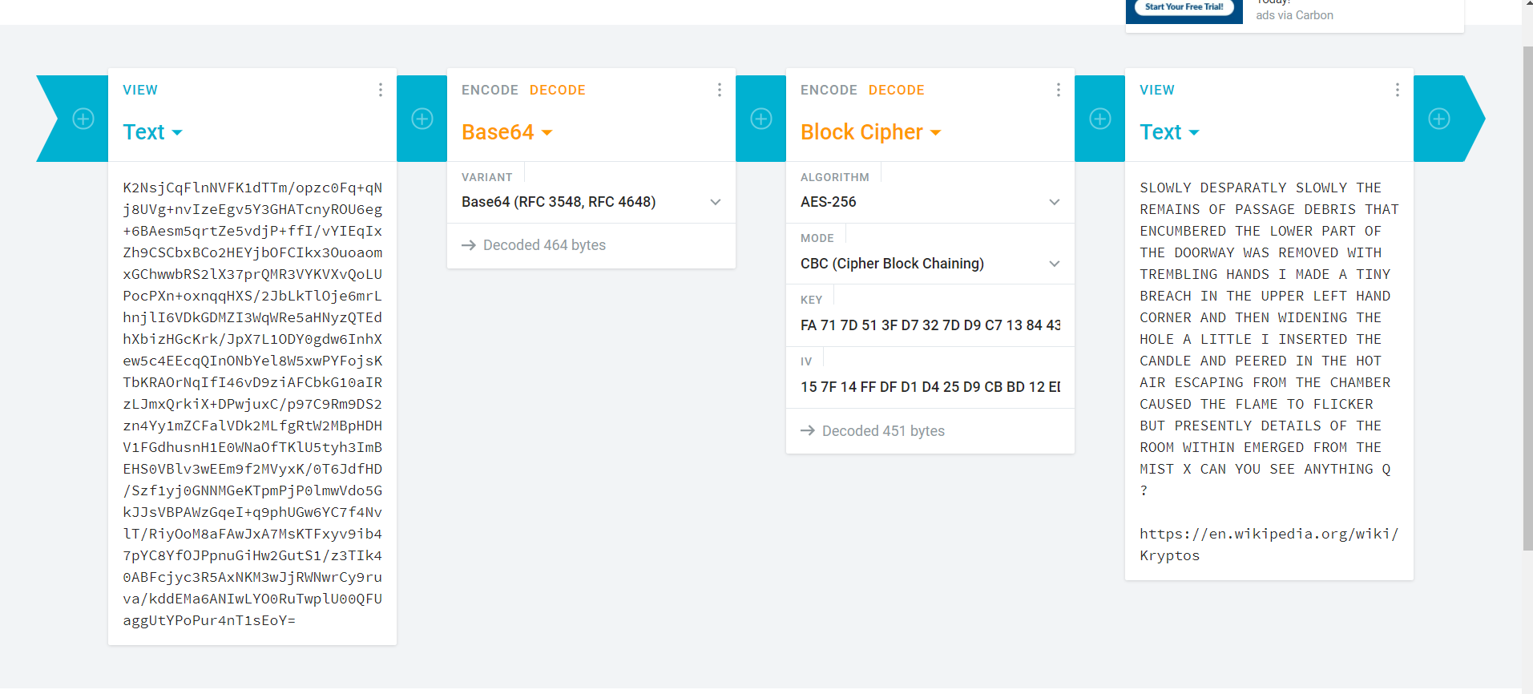

Question: What is the URL included in the plaintext you decrypted with AES?

Ans: https://en.wikipedia.org/wiki/Kryptos

**Message Sharing**

**key=19513FDC9DA4FB72A4A05EB66917548D3C90FF94D5419E1F2363EEA89DFEE1DD**

**iv =A74AA670A5B4FFB3898B272BCFEC7FC3**

1. Question: How did you ensure that the key exchange was safe? How would you exchange keys if you were not in the same location?

Ans: Key exchange (also key establishment) is a method in cryptography by which cryptographic keys are exchanged between two parties, allowing use of a cryptographic algorithm.

If the sender and receiver wish to exchange encrypted messages, each must be equipped to encrypt messages to be sent and decrypt messages received. The nature of the equipping they require depends on the encryption technique they might use. If they use a code, both will require a copy of the same codebook. If they use a cipher, they will need appropriate keys. If the cipher is a symmetric key cipher, both will need a copy of the same key. If it is an asymmetric key cipher with the public/private key property, both will need the other's public key.

There are two main ways**: Key Encapsulation Mechanism (KEM), or a Key Exchange (KEX).**

In a KEM, Alice will create a symmetric key from a CSPRNG or TRNG, sign it with a private key and encrypt it with Bob's public key. RSA would be a scheme that can handle this.

The other option is KEX. This is when Alice and Bob both generate ephemeral keys (with ECC for example). They both sign their ephemeral public keys with their static private keys and send them to each other. Both Alice and Bob combine their own ephemeral private key with the other's ephemeral public key (EC point multiplication in the case of ECC), and end up with the same shared secret. This is a point on the elliptic curve, so it will be passed through HKDF, into the correct format and length for the symmetric key.

This symmetric key MUST NOT be public, as it would defeat the point of encryption as anyone could decrypt the ciphertext.

2. Question: Which of the parameters of a block cipher (e.g., algorithm name, mode of operation, IV (if any), key length) are essential to keep secret? Security through obscurity does not count as "essential".

Ans:

I believe that it is essential that you keep the key secret.

If there is any other aspect of the cipher that you must keep secret (that is, you become insecure if it is revealed), then your cipher is 'broken'.

We can assume that the attacker can learn any long term aspect of your cipher implementation, such as the cipher name, mode of operation, key length. There are a number of possible ways they might learn it, such as an employee accidentally (or deliberately) leaking it, or if the attacker just obtains your implementation and dissects it. Hence, for security, we want to depend solely on something that we update routinely (such as the key). If the attacker learns the key, that limits the damage (as they can decrypt the traffic encrypted with that key, but nothing after we update the key). This idea is referred to as Kerckhoff's principle.

Now, you list the IV; that is typically updated constantly. On the other hand, we generally use it to refer to information that need not be secret. If it does have to be secret, then it really is part of the key, and should be considered that way.

**Week-7 Part-2 Assignments Lab:**

**Public-Key Infrastructure (PKI) Lab**

**Enclosing all the screenshots of the SEED Lab Assignment on Ubuntu VM machine:**

